Pit Scouting Data

Autonomous Notes

Wheel Type: #Wheels:

Drive train: #CIMS:

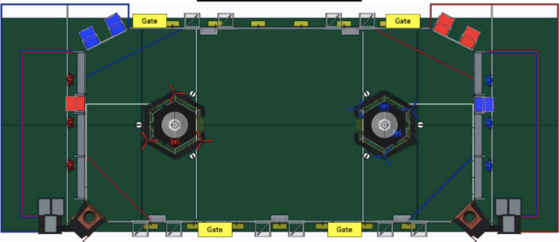

***Shooting*** Low Goal / High Goal / No

***Preload Gear***Y/N ***Climbable*** Y/N

***Floor Intake*** Y/N

***#Gear Cycles:***

***#Balls Holdable:***

Tele-operated Notes

Preferred strategy:

Balls / Gear / Ball + gear

Weight:

***Receive & Deliver Gear*** Y/N Human player / Floor pick up

*Additional Notes*

t-shirt color:

Friday night  
Qual Average: __

OPR: ___

Rank: ___

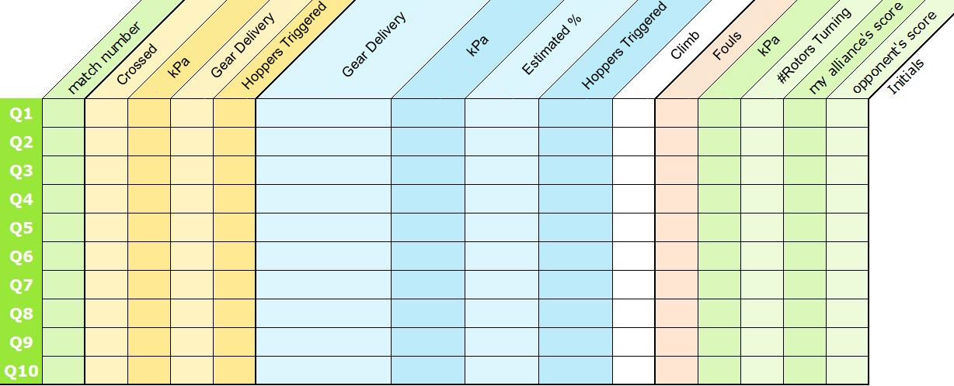

**Team Neutrino**

Driver info:

Human Player info:

Visual description

#

FRC #3928

Alliance color