Dear Sponsors,

Now that our in-season activities for our 2016 game, FIRST Stronghold, are over, we would like to thank you all for making this adventure possible. We have been able to accomplish so much thanks to your generous donations! Here’s a snapshot of what we’ve done with your support. For more details (and pictures!), please visit our website at www.teamneutrino.org.

Build Season

Our six-week build season kicked off on Saturday, January 10th. We watched this year’s game animation and were amazed at the unique challenge FIRST expected us to do this season. We were required to collect boulders and shoot them into goals for points, as well as gain points by crossing the various obstacles placed in the center of the field. We got to brainstorming right away, and soon had a plan for what we wanted our robot to do and look like. After we tested our idea, we CADD’ed it and sent off most of the parts to be fabricated off-site. We also machined key components of a field and a few parts of our robot using ISU’s Boyd lab. Students worked alongside mentors while learning different skills from them that can be directly applied to an engineering career.

At the end of our season, we showcased our robot to the public so they could see what we were able to accomplish. We couldn’t wait to bring our robot to the competitions!

Iowa Regional

We traveled down to Cedar Falls, Iowa for our first FRC competition of the season, which was also the first ever Iowa FRC Regional! We had a lot of new members join the team this year, and so it was a lot of fun to be able to share the competition experience with them. We also enjoyed competing with other teams from around the Midwest (and Brazil!). Some of these teams were ones we had assisted and/or mentored, and seeing their growth and success was rewarding. We ended up being in the 7th seeded with partners 167 and 3026. Our alliance made it to the quarterfinals.

Minnesota North Star Regional

We travelled up to Minneapolis again this year for the North Star Regional. We were chosen to be on the 4th seeded alliance, and we made it to the semi-final rounds with our alliance partners 4778, 2225, and 3026. Our team was awarded the Judges’ Award, a prestigious award given to selected teams.

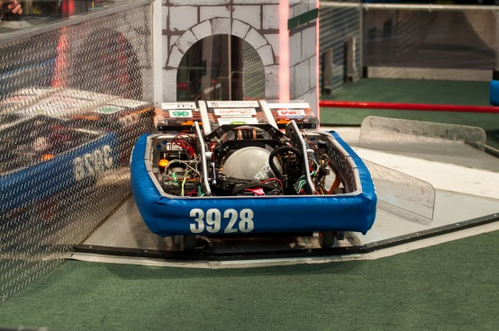
Summer plans
This summer, we will be teaching a LEGO Mindstorms class and Engineering 0.101, along with working together with a local elementary school to run a MakerSpace class. We also plan to participate in several outreach and fundraising events, and we will continue our newsletters monthly so you can stay updated. Thanks again, sponsors, for all you’ve done. None of this would be possible without your support!
2016 Robot

Lucas

Thank you for supporting FRC Team Neutrino. We greatly appreciate your contributions and support. We use your money to support the building of our robot and our traveling to competitions. It's also fun to visit your facilities to see how your businesses run and nice to know that we have the support of our community behind us. Our build season went well. We made it into the quarterfinals at the Iowa Regional and the semifinals at the Minnesota North Star Regional with our robot, Quantum. My favorite memory from build season was at the end of week three, when we gathered around our practice area to see our new drive train run for the first time. I really felt like a part of the team and like I had contributed to something great. Thank you for helping support these experiences on this amazing team. We hope to keep working with you in the future! Thank you again!

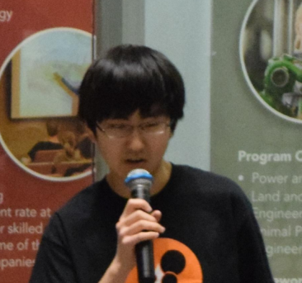
Ryan
I would like to express my gratitude for the generous contributions that our sponsors have made on behalf of our robotics team. As a rookie member of the team this year, I have acquired a wealth of skills from participation in the team, including dynamic activities such as learning how to work with instruments in the shop to more personal roles like teamwork and collaboration. Without the monetary support and funding provided by our sponsors, I would be deprived of this fun and educational experience, and I would like to acknowledge the efforts taken by sponsors that have greatly improved the condition of our team. As a potential returning member to Team Neutrino next season, I hope that I can continue to enjoy the great benefits that have been brought about as a result of our sponsor efforts!

Benjamin
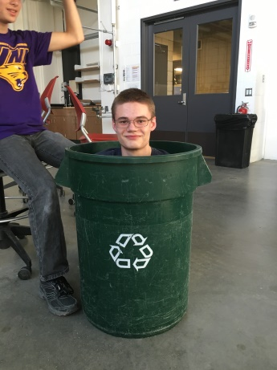
As the leader of the mechanical and website subteams and drive coach, Team Neutrino has been a great learning experience for me. This year, I focused on both designing and building the robot. Through Team Neutrino, I was able to learn much more computer aided design plan our robot. While I had learned how to do this kind of design in school, Team Neutrino provided me with a practical use for those skills and provided incentive to continue learning. When building the robot, I learned how to machine different raw materials into robot parts. I learned how to use the lathe this year and that was very useful! Team Neutrino greatly enhanced my mechanical skills this season.
In addition, Team Neutrino has helped me learn other skills. Partly through managing our team’s website this season, I have learned writing and html skills. Learning how to communicate and work with others is integral to our team’s success. Figuring out how to plan with others will help me in the future when I have to collaborate. This year, I also had the privilege of coaching our drive team. This helped me improve my communication and strategy skills. It was great to see all of the hard work we had put into it finally pay off.
Sponsors allow our team to both inspire and teach many new students each year. The money and parts that are donated help us create a competitive robot and team. By sponsoring our team, you are helping to improve the futures of not only me, but all of my teammates. Thanks for your support!
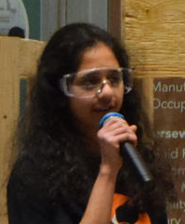
Rucha
Thank you so much for your contributions to Team Neutrino. If it wasn't for sponsors like you, our team would not exist. Through this past season on Team Neutrino, I've gained a number of invaluable skills that will stick with me for life. I never imagined that I could be this passionate or knowledgeable about STEM concepts and organizations, but I'm so glad that I am. The team has provided me with real world STEM experiences and applications and gave me hands-on activities to utilize my knowledge. Without the team, I would not have been as confident, efficient or organized as I am today. Thank you for sponsoring Team Neutrino

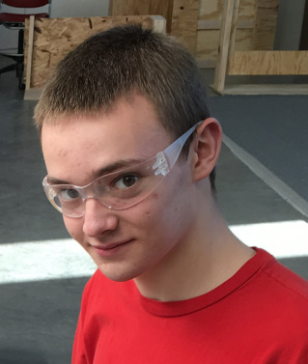
Joel
I’m a New-trino who joined without any idea of what I was doing. After being on Team Neutrino for a year, I’ve learned a lot. A few of the things I’ve learned include CAD, wiring, and robot fabrication. Everything I’ve learned was made possible by our sponsors. The funding we receive lets us learn and teach about engineering in a fun way by building a robot and then taking it to competitions. Thank you sponsors!

Dagney

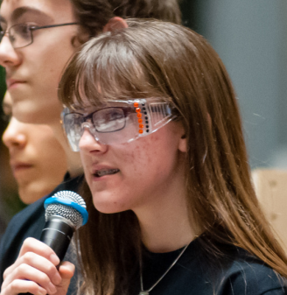
I can't believe that my time on Team Neutrino is already coming to an end! I've been a member since my freshman year in 2013, and in these four short years, our team has made it to the finals three times, qualified for worlds, started Jr. FLL in our elementary schools, and inspired countless students to pursue careers in STEM through our community outreach. I personally gained a lot of experience in talking to sponsors through annual

visits, and I would like to thank each of you for the support you show to Team Neutrino. Next year I'll be going to Iowa State University to major in engineering (currently undeclared), and I hope to someday get a job at the Science Center of Iowa designing camps and programs. Once again, thank you for your commitments this past year, and I hope that you'll continue your support for many seasons to come!

Obi
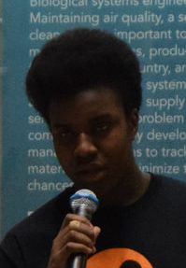
Because of the time spent as well as money from our sponsors, the team was able to learn and enhance our ability to CAD, code, craft and build. Though we did not win the competition, we were able to have fun and branch out. Many of the new team members had fun coming to these competitions, being able to help out and be active with the team and meet other teams. Our sponsors were able to help us achieve what we could and support us through another season.

Timothy
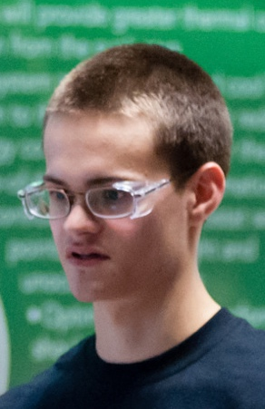
Through FIRST Robotics and Team Neutrino, I learned the process of designing, building, and programming a robot while having fun working with others. Team Neutrino has given me the opportunity to learn from experienced mentors. Through programming the robot I learned both C++ and Java. I also learned how to use tools to machine, assemble and wire the robot. I not only learned technical skills, but also gained problem skills, communication skills, and leadership skills. FRC has excited me about engineering in a way like no other. This would not be possible without the support of sponsors and mentors. I am glad to have this wonderful hands-on learning opportunity and hope that it will continue to be available for future generations of high schoolers.

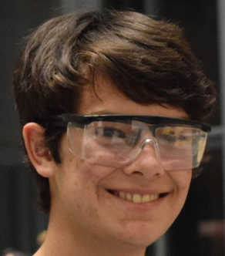
Evan
Hello, sponsors. I just wanted to take a moment to thank you for all that you have done for our team in this past season, whether it was monetary or an in-kind donation. Your contributions have given me the opportunity to expand my technical skills in the area of electrical engineering and machining. I am a proud member of Team Neutrino and thank you for your continued support of our team.

Bekah
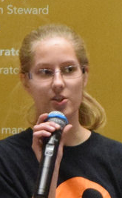
Thank you so much for supporting Team Neutrino this past season. This was my very first year on the team and I was extremely lucky to get the chance to work with the fundraising subteam. Through outreach, I was able to recruit and meet many of the team's supporters and sponsors. Thanks to you, I had an amazing first season and plan to continue working in STEM.

Nathan P.

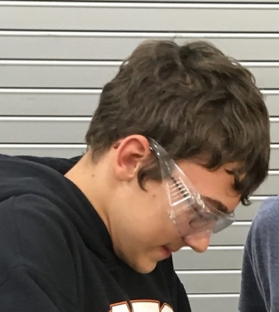
Through the contributions to Team Neutrino from our sponsors I have been able to learn many new skills through the opportunities it offers its students. This will be my third-and-a-half year involved with Team Neutrino and the skill I have now I would never have had without the FIRST robotics program. Your contributions to the team specifically help kids in Story County to learn the skills needed for a major in engineering and so much more.

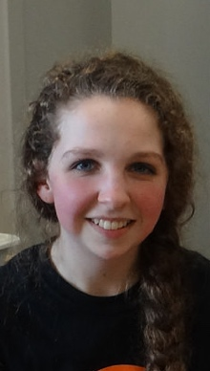
Moriah
Thank you! Without your support, this team would not exist to the extent it does today. Through the team, I have entered a world that is full of real-world things to be learned, from the mechanics and process of building a robot to the inner workings of keeping a team like this running. I know for sure that the experience I gain from being a part of this team is experience that I can use to enrich the rest of my school career and life after school.

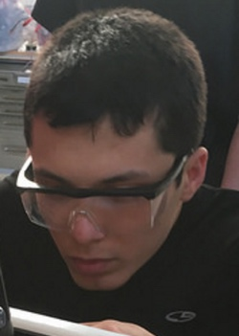
Logan
Throughout my time on Team Neutrino I have improved my knowledge in STEM and public speaking. I have been able to apply the knowledge that I learned in school to robots. I’ve learned how to be a leader and inspire students. Team Neutrino has inspired me to pursue a STEM major.

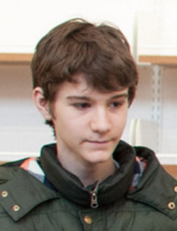
Nathan S.
Team Neutrino is truly a great opportunity, not only for me but for many others. When I joined Team Neutrino, I thought it would be fun. It turned out that it was fun, but it was also much more than that; it was an opportunity. It wasn’t just an opportunity to build a robot or win a competition, but it was an opportunity to learn. I learned so much about STEM from joining Team Neutrino. For instance, I knew how to program when I joined the team, but I had no idea how to make a robot do anything. In just a month, I could do a wide variety of things with our robot, which could easily carry over to a career. However, I’m not the only one who’s learned a lot; almost everyone who joined the team has learned a valuable skill in STEM. However, Team Neutrino can only teach us all valuable skills because of your funding. I would like to thank you for providing this learning opportunity for us all.

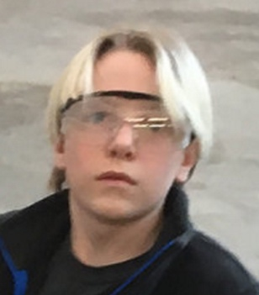
Daren
At the beginning of the year, I didn’t really know how to program anything, wire up a robot, or work efficiently as a team. However, after my time well spent on Team Neutrino, I can code a pretty basic program for our specially designed robot, wire a shooter, and function very well in a group. If it wasn’t for Team Neutrino, I wouldn’t know how to do a lot of the stuff I know how to do now, and I owe it all to Team Neutrino.

Tianxin

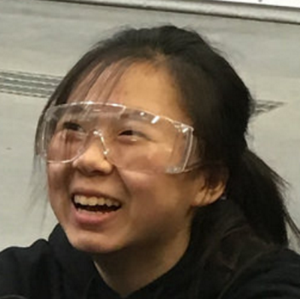
2016 was my second year as a part of Team Neutrino and FRC. It was really great because I was able to get involved in more areas of the team. I learned how to wire the robot, acted as the coordinator for many team events, and presented about our team at many events. Without your support, none of this would have been possible. From briefly ranking 1st to a one point win in the quarterfinals, competitions this year have been the most exciting experience yet. None of this would have been possible without your funding and we really appreciate your support. I’m not sure I can accurately capture how much the team has influenced me and how much I enjoy and appreciate being a part of it. Thank you for making this experience as rewarding as it has been.

Hana
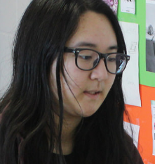
I want to give a huge thank you to you for all of your support this season. Your help has made it possible for my team members and me to be a competitive team at this year’s regionals. Over the course of the year we have been trained in CADD, machining, wiring, and programming. Without FIRST and your sponsorship, none of us would have been able to experience any of these opportunities! Thanks again! Team Neutrino has opened up a lot of opportunities and learning experiences for me, including competitions, the robot, and outreach. It was definitely a highlight during my year and I’m extremely looking forward to another year of being apart of the team. Thank you so much for sponsoring our team and allowing everything amazing to happen—I appreciate everything that you’ve done for us.

Antonio

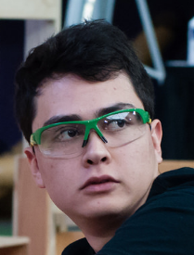
Neutrino is a big opportunity for people to get involved in real-world technological problems. STEM skills are basic for people at this time, and Team Neutrino is a good way to learn more about it and take more advantage of technology. All we do in Neutrino would not be possible without the help of our sponsors. Thank you for continuing to help us in our mission of learning and returning it to the community.

Nick

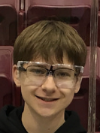
Our sponsors are probably one of the most if not the most important part of Team Neutrino. Without sponsors almost none of what happens in Team Neutrino would be possible. From the beginning to end of each year there are countless aspects of what we do that require a lot of sponsor support. Our sponsors are what drive the team and they’re completely invaluable. Thank you to our sponsors for making everything Team Neutrino does possible.

Woo Young

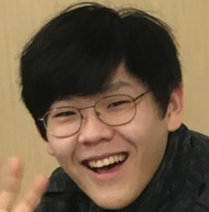
Thank you sponsors for supporting our robotics team. Through the team, I've learned a lot this year. This year as a co-manager of scouting and manager of the CADD team, I was able to learn how to be a leader. Without all the sponsorship, we wouldn't have been able to come as far as we did. Thank you for sponsoring us.

Conor

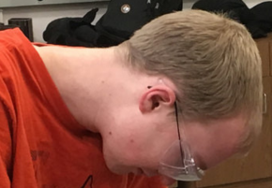
Thank you for making this year's season possible! I learned so much over the year and none of it would be possible without your support. I really enjoyed building upon my knowledge of wiring/electronics throughout the season. It was an amazing experience to learn from our talented mentors

and students while making this season's robot. I was very proud of how we did and look forward to seeing the team grows next season. These experiences have been very useful as I now prepare for college. Having experience with all sorts of engineering experiences has been super helpful when deciding on a major and classes in college. Without FIRST, I doubt I would be in the position I am now of knowing what I am skilled at and what I want to pursue as a career. Thank you again for making this season a great one!

Jacob

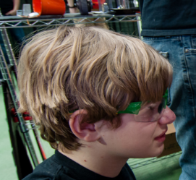
Thank you for sponsoring us for the 2016 year. Thanks to your funding and help, I was able to develop many new skills and meet a lot of new friends. I have enjoyed this year's season and hope to be able to enjoy next year’s challenge with your gratuitous support. Thank you for sponsoring us.

Tifany

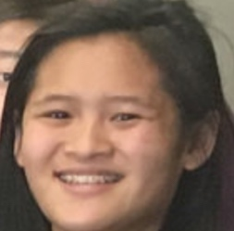
Thank you so much for sponsoring Team Neutrino. All of us greatly appreciate your generosity and support. I have been on Team Neutrino for three years and through these past three years I have learned so much. Your continued sponsorship has helped our team become as successful as we are today. This program has taught me so much and I would like to sincerely thank you guys!

Helen

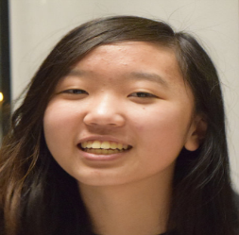
I would like to express my gratitude, on not just the behalf of myself and my FRC team, but also speaking as one of the many students passionate about STEM. Organizations and businesses like yours are the ones who unlock a whole world of opportunities and pave a road for the future generation to walk along, and someday, even build off of. The support you provide is what gives us the ability to develop our ideas into projects and adapt skills in an natural and engaging environment. Your passion for revolutionizing science and engineering and dedication to reaching out to students is what inspires our team and makes us proud to partner with you, and for that, we would like to give you an unfeigned thank you for everything.

