Dear Sponsors,
As we wrap up our in-season activities for 2014’s game, Aerial Assist, we’d like to give a warm thank you to you for making this adventure possible. We have been able to accomplish so much thanks to your generous donations! Here’s a snapshot of what we’ve done with your support. For more details (and pictures!), please visit our website at www.teamneutrino.org.

Build Season
Our six-week build season kicked off on Saturday, January 4th at ISU, where we watched this year’s game animation. We were filled with shock and awe at what FRC expected us to do this season: pick up, pass, and shoot a 2’ diameter exercise ball into two levels of goals with two alliance robots in under three minutes. We got to brainstorming right away, and pretty soon, we had a working prototype.
After we tested our idea, we CADD’ed it and started the machining process using ISU’s Boyd lab. Students were able to work alongside mentors while learning different skills from them that can be directly applied to an engineering career.
At the end of our season, we showcased our robot to the public so they could see what we were able to accomplish. Our robot turned out to be highly competitive, and we couldn’t wait to bring it to competition!

Greater Kansas City Regional
We traveled down to Kansas City, Missouri for our first FRC competition of the season. It was so much fun to get this experience and be able to show our robot to the other teams! We ended up being ranked 9th and captains of the 6th alliance with alliance partners 2410 and 3172. Our alliance made it to the quarterfinals.

Minnesota North Star Regional
This time we went up north for our next regional which was in Minneapolis. Because of the experience we gained from Kansas City, we were able to have the 2nd highest Offensive Power Ranking, which translates to having a robot that is the 2nd best at playing offense. We were chosen as the first choice of the 2nd alliance, and we made it to the quarterfinals. The team was chosen to be the recipient of the Engineering Inspiration award, which is given to the team that not only has a highly competitive robot, but also has a strong outreach program to inspire the community to explore the STEM field. The award included a ticket to the global Championship in St. Louis paid for by NASA!

FIRST Championship
Team Neutrino was elated to compete in this year’s FIRST Championships. All four FIRST programs were present, including Jr. FLL, FLL, FTC, and FRC. It was a very exciting event, as you can imagine, with more than 600 teams from 38 countries packed into the Edward Jones Dome in St. Louis, MO. We had a win-loss record of 6-4, and during alliance selection, we were picked to be the 4th robot on the 4th seed alliance (in the Newton division)! Our alliance partners were Team Titanium, Team Kiki Mana, and S.W.A.T. Sadly, during elimination rounds, Team Titanium’s drive train was unable to be fixed, and so we had to substitute our robot in during the semifinals. Our alliance lost to the 1st seed, but won in the second match, forcing a tiebreaker round!! We ended up being semifinalists on the Newton field (similar to the Sweet 16 in March Madness). Then we packed up and went to the other side of the dome to watch the Einstein matches (final four). Congratulations to team 27 for winning the global Chairman’s award, and to teams 1678, 1114, 1640, and 5136 for representing Newton field in the final matches!

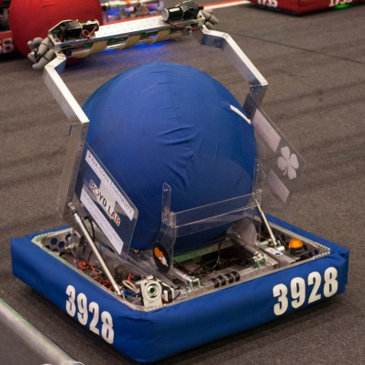
Summer plans
This summer, we are planning to participate in several outreach and fundraising events. We will continue our newsletters monthly so you can stay updated.
Thanks again, sponsors, for all you’ve done. None of this would be possible without your support!
2014 Robot

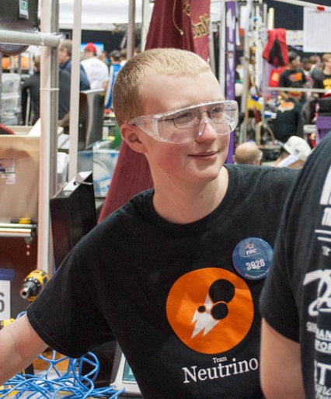
Conor
Thank you for making this year's FRC season possible. Sponsors are very important for helping us get the resources we need to learn about engineering. Without the FRC experience, I would not know nearly as much about what I want to do in my future as I do now. I have learned about what all goes into a complex robot. I was able to try out different types of jobs on the robot this year like wiring, programming, and using the machines in the shop. I also got to learned how the engineering process works from design all the way to the competitions. It was also amazing to be able to learn from talented mentors that teach us so much more than just robotics. Your help has given me countless opportunities and experiences that will help me as I continue to learn and grow as an engineer. Thank you!

Jeremy
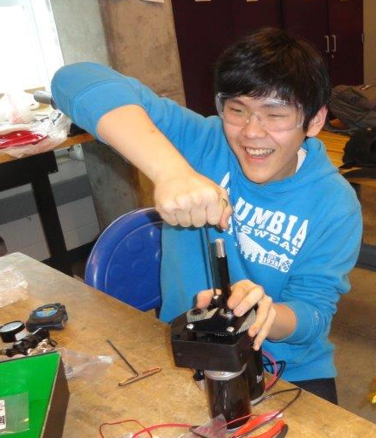
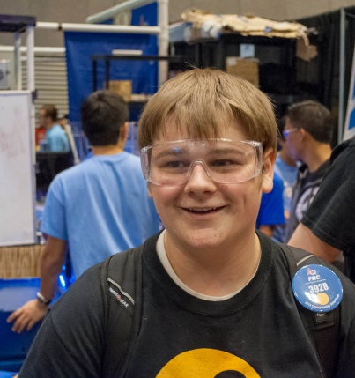
“Thank you” just simply cannot describe how grateful I am to our sponsors for their support. What you give us extends beyond simply donations to help us build a robot. The donations we get from sponsors opens doors for us that were previously closed to my teammates and me. Thanks to you we now have the capabilities to learn as much as we want about science, technology, engineering and mathematics, so to all sponsors I would like to say thank you for helping the team and myself figure out our futures.

Woo Young
Thank you for supporting us throughout the season of 2014. Because of the support we were able to achieve much more than what we could have without the support you guys had. We were able to go to the World Championship in St. Louis, and people who joined in the season of 2014 got to learn many things. For example, I learned how a robot is produced from brainstorming to assembling. Once again, thanks for the support to our team.

Kate
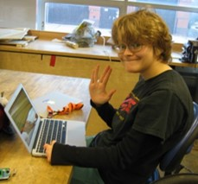
I've been in FIRST for a long time, starting with FLL. I learned a lot from that experience, but while working in a lab on an actual robot instead of one made out of legos I really got to understand what engineering jobs are like. Before I assumed that the lab would have looked like a supervillain's lair, and it sort of does, but not in the way I expected at all. My experience with Team Neutrino has really helped me gain a better understanding of what engineering is.

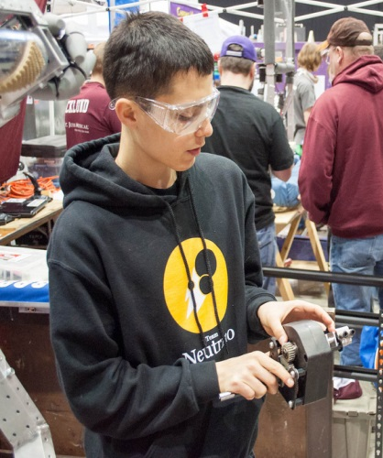
Logan
Without the help of sponsors it would have been impossible for me to have learned about electronics, programming and mechanics. I have enjoyed participating in a FRC team and actually applying the engineering skills I learned there, all of which would never have happened without sponsors. The help of sponsors also allowed me participate in regionals and compete against other FRC teams there. All in all, none of this would have been possible without the help of our sponsors.

Timothy
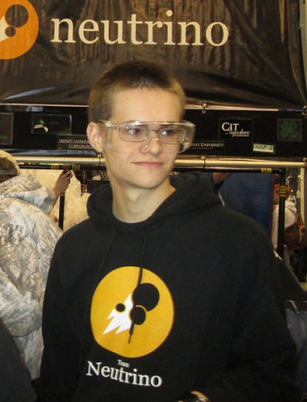
Thanks for supporting Team Neutrino. Team Neutrino has made a major impact on my life and it wouldn't be possible without sponsors. Through the FIRST Robotics Competition (FRC) and Team Neutrino, I have learned about designing, building, and programming a robot while having fun working with others in Team Neutrino. I have learned from the professional engineers, ISU mentors, older high schoolers on the team. Before I joined Team Neutrino I did not know how to program in Java. Through programming the robot I have learned Java. I also learned how to use tools to machine, assemble and wire the robot. I have learned more than just technical skills, but also how to work with others on a team and communicate ideas. FRC has gotten me excited about engineering in a way that I couldn't have been from anything else. This would not be possible without the support of sponsors. I am thrilled to have this wonderful hands-on learning opportunity and hope that I will be available to future high schoolers. I would like to thank all of the sponsors that make this possible.

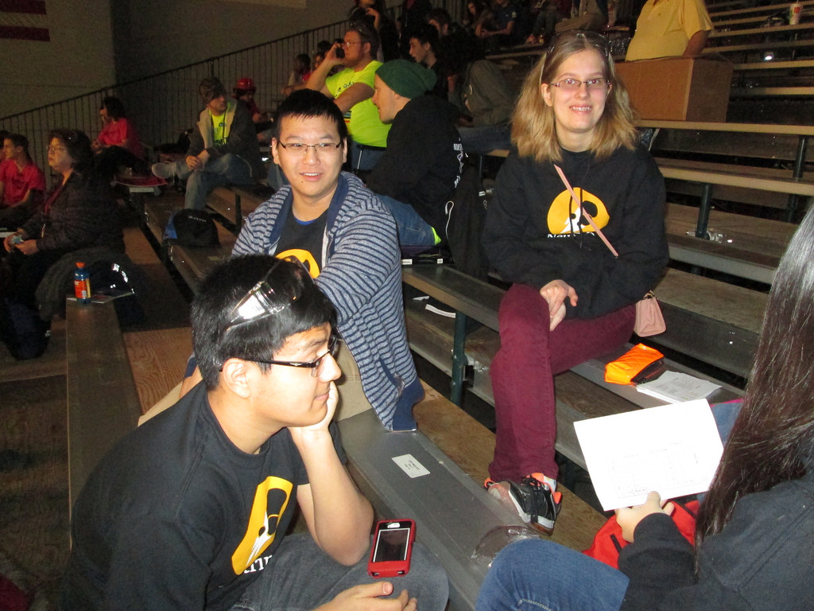
Zhi
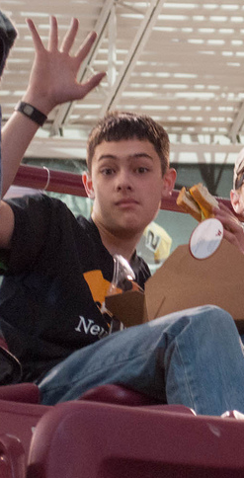
Because of our generous
sponsors, we were able to attend two regionals this year and the championship tournament. Each one of us learned a lot throughout robotics this year.

Evan
Thank you for helping us to get all the way to world championships. I had a blast this season and we couldn't have done it without you. I have gotten several experiences I would not have had the opportunity to do otherwise. Big thanks from all of us on team Neutrino and I hope to see you next year!

Bekah
One thing that I have learned about was the basics of connecting wires together and pneumatics. The importance of sponsors of our team is getting us to competitions. The sponsors are a huge support to our team to help us get to everything like the competitions.

Binaya
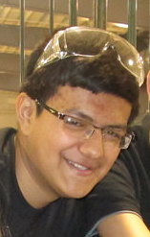
Sponsors are part of the foundation of Team Neutrino. They provide us with funding so that we are able to build robots, teach young students about the world of robots and encourage them to pursue robotics as a career or even just a hobby. Without our sponsors we wouldn't be able to compete in competitions. We wouldn't able to function and be Team Neutrino, so we need our sponsors and we are very thankful to them for supporting Team Neutrino. I've learned so much from being in Team Neutrino. Being a part of this team has helped me to learn about the processes of coming together and making something big happen, in this case building an awesome robot. I've learned a lot more about robots and how they are made. Being a part of this team gives students something to do after school and also to learn. I've had a lot of fun being part of this team and I hope to keep being a part of it for as long as I can. Sponsors Rock!!

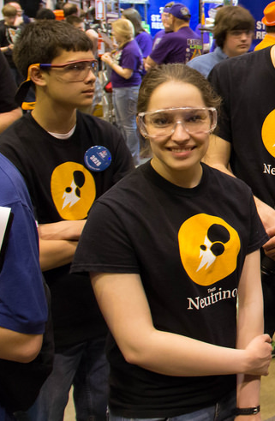
Rachael
Team Neutrino & FIRST are the most incredible organizations I have had the opportunity to participate in. So many doors have been opened to me; learning new things in engineering, electronics, business, and public relations. I have been able to work with equipment I would have never been introduced to otherwise; people I would have never met and I have had life-changing experiences that I will treasure together. None of what we are able to do would be possible without support from sponsors and our community. Whether it be monetary support, mentors, in-kind donations, or community support, every amount of support fuels our team on our road to success and for that we are eternally grateful.

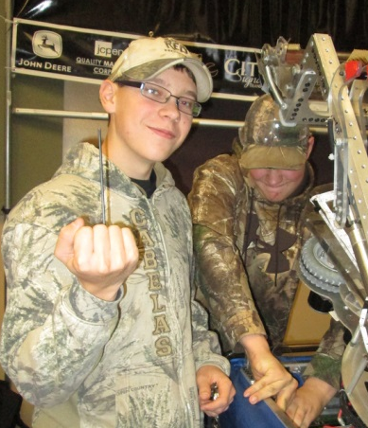
Matthew and Kyle
We learned how to get something done on a time crunch. Sponsors make it possible for everything to happen. We were able to make the time crunch thanks to the use of time management and the great help from the sponsors.

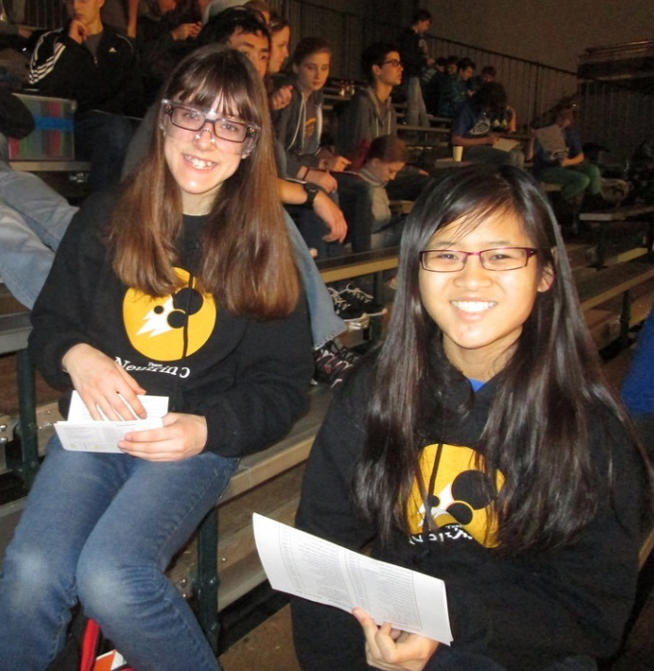
Dagney
Thank you,
sponsors for all of your support this season! Because of you, I was able to become more confident in business relations and taking a leadership position. I also learned how to write strong essays and grant proposals, as well as organize outreach events and team meetings. This year was just as exciting as last year, and everyone on the team was able to expand their knowledge and love for the STEM fields. Thank you so much for all that you do for our team!!

Tifany
Being on Team Neutrino during this past 2013-14 season has taught me MANY valuable lessons. For one, I learned how to use shop equipment and learned all about CADD etc. Furthermore, I've learned all about teamwork and that if we set our minds to it, together we can really accomplish amazing things. It was incredible watching a robot grow from just a few pieces of metal and wiring. The sponsors were definitely a key part of our success. Our sponsors provided us not only with the money, but also the materials we needed to build such an amazing robot. Without the sponsors, there wouldn't be Team Neutrino. So I, Tifany Chu, would like to thank you, the sponsors for all your support this year!!!

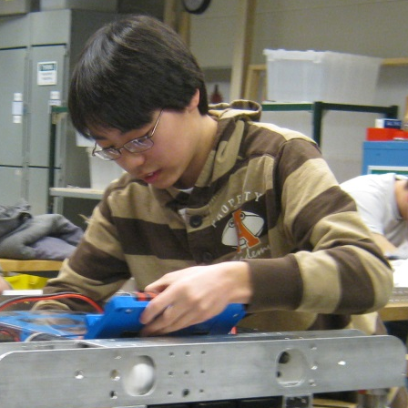
Takeshi
Over the course of this FRC season, I have learned an unbelievable amount about both the practical aspects of engineering and what it takes to work as a team to accomplish a common goal. And what a success, too! Against all odds, we were able to overcome many obstacles and make our way to the world championships. All this would not be possible without you, the sponsors. The skills we learn are building the foundations for the next generation of workers. Your generous contributions are helping our dreams become a reality. As we continue to grow, I hope you know that our sponsors were vital to our success. You are truly appreciated. Thank you.

Thank you!

