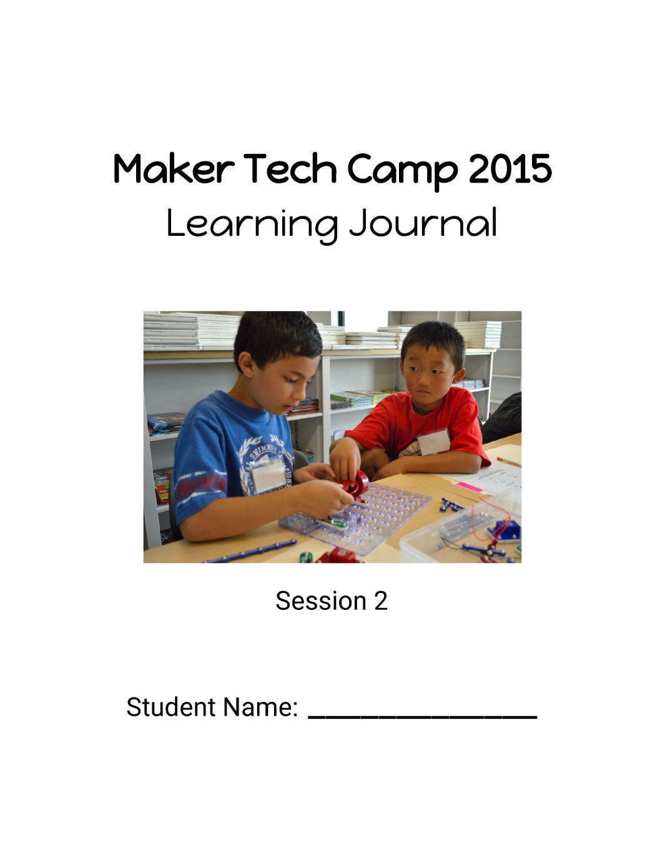**Maker Tech Camp – Session 2**

*Teacher’s Guide*

Welcome to the Maker Tech Camp, developed by Teresa Green and FIRST Robotics Competition (FRC) team, Team Neutrino #3928!

This document includes lesson plans for several activities you could include in your tech camp. Feel free to use one lesson, two lessons, or the entire document. Mix and match lessons with what you have at your elementary school. You could also use these worksheets during the school year.

We recommend that you use these lessons for kids going into **grades 4-6**. See session 1 for kids going into grades 2-3.

The “Learning Journal” can be assembled in several ways. We suggest using a report cover, a three- pronged folder, a three-ring binder, or something else that is easy to add to and take from. You’ll want to keep the surveys on pages 1 and 12-13.

Use this survey before and after the class in order to get an idea of how effective it was. If you do it on paper in their learning journals, you can slip it right out before they take them home.

Some students might be wondering if they’ve ever programmed LEGOs before. If they ask, you could explain that this includes RCX, NXT, EV3, and WeDo. If they’ve been on a Jr. FLL or FLL team before, they’ve most likely programmed LEGOs. If you choose to do the LEGO education lesson from session 1, they will all have programmed LEGOs by the end of the class.

Start this lesson by explaining what 3D printing is and how it’s used to solve real-world problems. If you’re on an FRC or FTC team, you could bring in examples of 3D printed parts you’ve used!

Have the students answer the questions either during or after your presentation. Go over them as a class.

Next, have the students create a simple model on a 3D modelling software. We used Tinkercad since it was free and easy to use. Go through the basics of whatever program you decide on, and then give the students time to work.

Tinkercad: <https://www.tinkercad.com/>

If the students are having trouble coming up with something to model, you could suggest making a keychain with their name on it, a model of a pet, etc.

After they create their designs, have them make sketches of their model from the front, top, and right side, and explain that from these three views, you can find out a lot about a model.

If you have access to a 3D printer, consider printing the students’ models as a unique take-home project.

**Lesson length estimate:** 45 minutes

You can either order Brush Bot kits from Make, or create your own kits using inexpensive motorized toothbrushes, copper tape, and 3 volt batteries.

Brush Bots: <http://makezine.com/projects/building-brushbot-kits/>

Introduce the students to Brush Bots using the video on this page. Ask them if they’ve ever played with hex bugs before and explain that Brush Bots are very similar.

Hex Bugs: <https://www.hexbug.com/nano/>

Give each student a brush bot kit (either ordered or self-prepared). Have them follow the project steps in their journals. You might have to modify the steps slightly if you made your own kit. For younger age groups, consider making the brush bots as a class.

After the basic bots are done, give them extra materials (i.e. pipe cleaners) and have them modify their bots to make them go straight or in a curve. Hint: If you put the motor on top of the battery, it should go in a circle; if you put it next to the battery, it should go straight.

Students should use the questions as a guide to the self-exploration.

Have them compete in Brush Bot games! Create your own or use these:

Race: Your bot must go in the straight line course in the least amount of time to win.

Brawl: Put three bots in a dish together. The last one to fall over wins!

The Race game can be made with rulers taped together in a line, or straight pieces from a hex bug nano kit. The Brawl game just needs a dish or a hex arena from a hex bug nano kit.

End the lesson by discussing the questions at the bottom of their journal pages.

**Lesson length estimate:** 1 hour

Begin the robotics lesson by seeing what students already know. Don’t give them any additional guidance besides what’s already on the sheet.

Next, discuss what robots are. Give examples of various machines and decide if they are robots (i.e. upright vacuum cleaner vs. Roomba). Ask students what they think a robot is and then fill in the definition at the bottom of their worksheet.

By definition, a robot is something that needs power, and then senses, thinks, and acts.

**Lesson continued with Cubelets and MOSS.**

Cubelets are a modular robotics education tool developed by Modrobotics. Check out the Cubelets page on their website to order them. This page also has short descriptions and pictures of each block.

Modrobotics: <http://www.modrobotics.com/>

Watch this short training video before the session starts to become familiar with how Cubelets work.

Cubelets introduction video: <https://goo.gl/XgXY2G>

Have kids work in groups of two or three. Start by handing each group three blocks. You can do this exploration with either Battery, Brightness, and Flashlight, or Battery, Distance, and Drive. Use the video below to give yourself some ideas, but let the kids explore on their own!

Seven ways to build a robot: <https://goo.gl/ae6qr2>

Switch out the brightness sensor for a distance sensor, or vice versa. Without telling the students what the new sensor block does, let them explore and figure out what it senses.

Now, switch out their cubes for Battery, Distance, and Drive. Have them make a robot that drives straight and then in a circle. As a class, discuss what they changed about the robot to change its direction.

Questions to guide discussion:

What can you do to make your robot go fast?

What makes the robot go slow?

How do you think you could make the robot drive across the table and stop when it reaches the edge?

Give each group a passive block and have them explore the new possibilities for construction. Finally, give them your choice of six blocks and have each group create their own robot.

Finish the lesson by explaining some real-world applications of what they’ve been learning. See if they can think of some applications of their own for Cubelets in their own lives before flipping to the challenge page in their journals.

Groups should choose a challenge to work on. They should describe the problem for the challenge they chose in their own words and plan their solution before getting the Cubelets to build a robot.

Have each group present their problem, their solution, and any challenges they overcame during the building process, including changes to their original plans.

**Lesson length estimate:** 2 hours

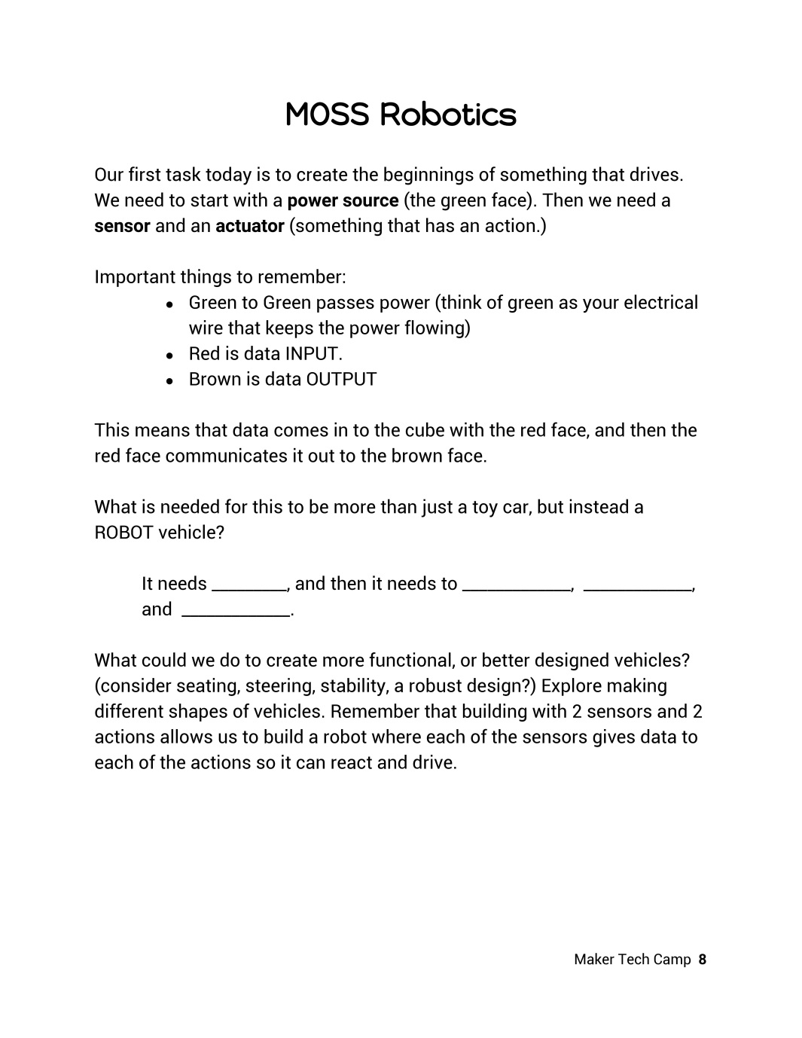MOSS are another modular robotics education tool developed by Modrobotics. Check out the MOSS page on their website to order them. This page also has short descriptions and pictures of each block.

Modrobotics: <http://www.modrobotics.com/>

Watch this short training video before the session starts to become familiar with how MOSS works.

MOSS teacher training: <https://www.youtube.com/watch?v=0loiNF4dI1U>

Have kids work in groups of two or three and walk them through the exploration in their journals. When the groups are finished building their vehicles, have them present them to the other groups.

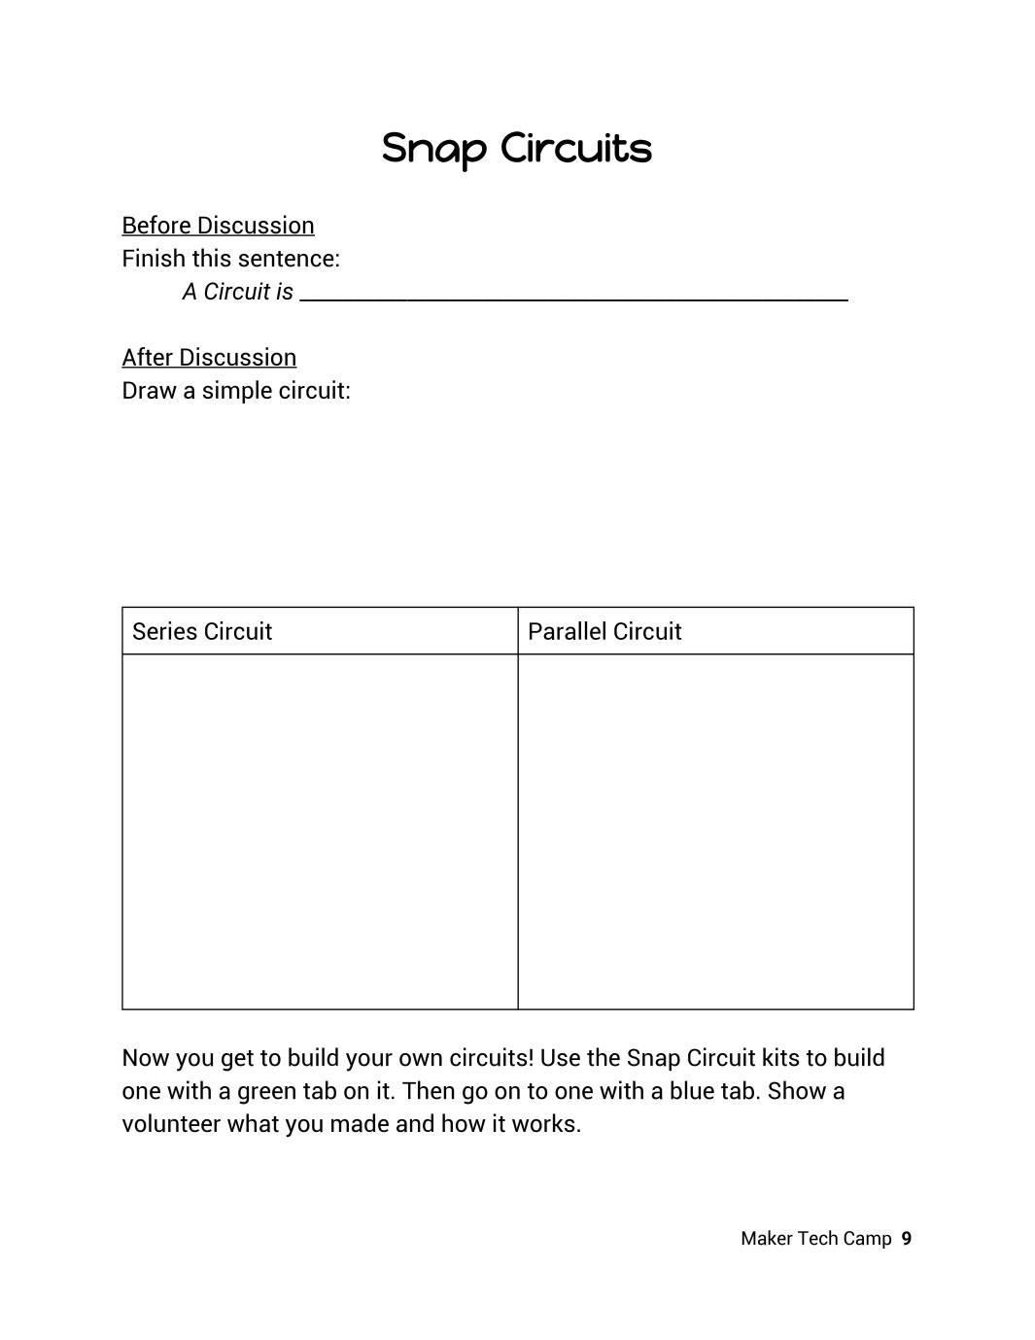Before you give the students any explanations or instructions, have them fill in what they think a circuit is.

Explain what circuits are, the difference between a closed and open circuit, and what a short circuit is. If you covered circuits when you did any of the earlier activities, like Brush Bots or robotics, you could relate back to those.

Use some Snap Circuits or Circuit Blocks to demonstrate a simple circuit. Show them how to draw the schematic diagram for what you made.

Snap Circuits: <http://www.snapcircuits.net/>   
Circuit Blocks: <http://www.ciplearningstore.com/>

Next, create a series circuit and draw the schematic diagram for that together as a class. Then do the same for the parallel circuit.

Put students into groups and have them build their own snap circuit projects. You could mark a few that you feel would be good examples to build. Make sure that the students know *how* their circuit works, and not just that it does.

Have the groups share what they did with the class.

**Lesson length estimate:** 45 minutes

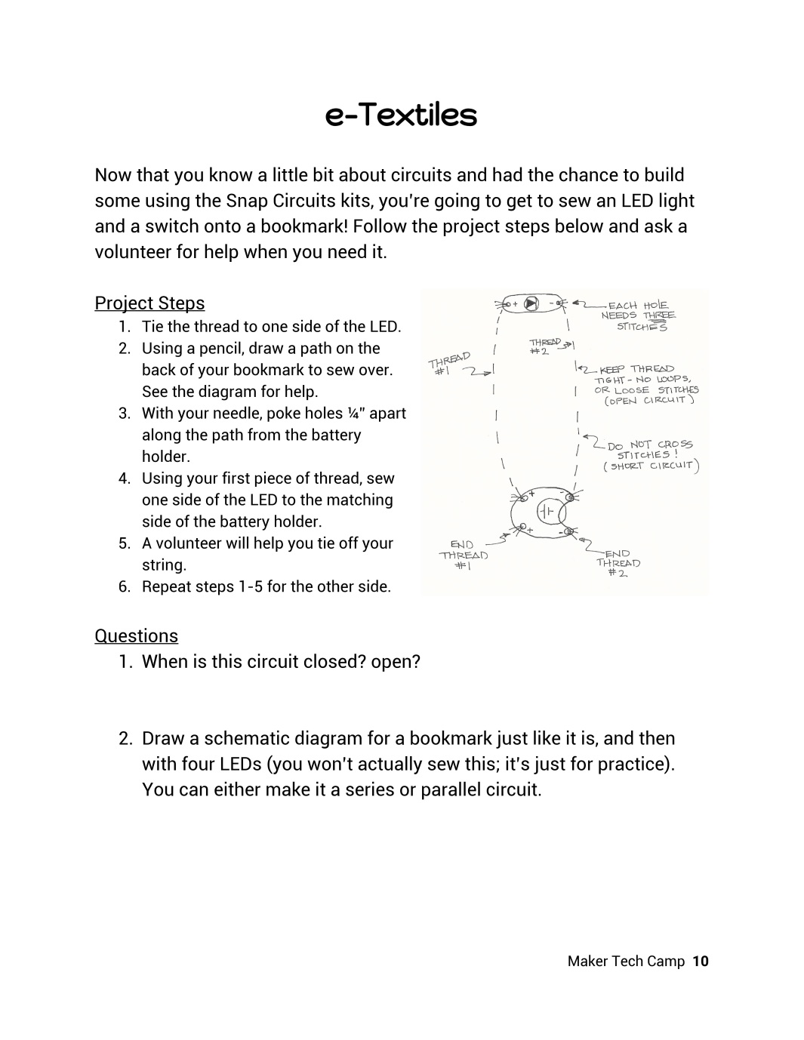This is an extension project to the Snap Circuit lesson. You’ll find information about the project, a list of materials, and ordering information at the link below. Just click “next step” and it will bring you to the list of materials.

<http://sewelectric.org/diy-projects/bookmark-book-light/>

Start the lesson by explaining how LEDs work. LED stands for “Light Emitting Diode.” A diode is a special component of a circuit because it only works well in one direction (compare to an incandescent (INC) bulb), depending on the voltage of the battery it’s hooked up to.

Depending on the age level of your students, you could describe a diode as a “one way street.” LEDs are special because they emit light with a current. With less current, they will emit less photons, and therefore, become dimmer. They won’t, however, change color like INC bulbs.

After giving the students a little background on LEDs, photons, light, electronic textiles, or whatever you choose, have them complete the e-Textiles bookmark project.

**Lesson length estimate:** 1 hour

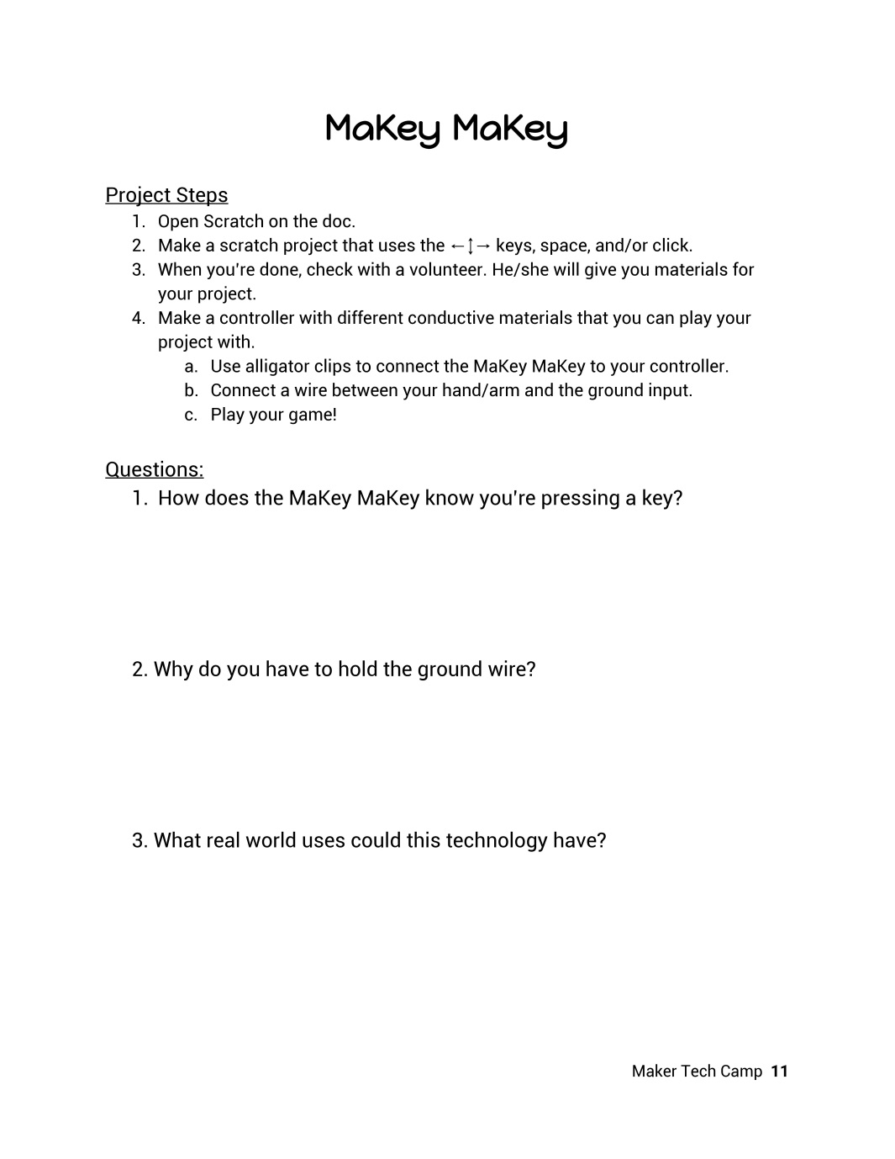A MaKey Makey can make conductive materials into keys for Scratch games! Find out about them at their site.

MaKey MaKey website: <http://www.makeymakey.com/>

In order to complete this lesson, you’ll also have to download Scratch, a free programming software developed by MIT.

Scratch: <https://scratch.mit.edu/>

If the students have not covered Scratch or programming in class yet, consider doing a lesson on basic programming first.

After the students have created their games, discuss what kinds of materials are conductive. Bring in a variety of materials (aluminum foil, bananas, apples, etc.) to try. Have the students come up with a way to test if the materials are conductive. For example, hook up a battery to a lightbulb to the material to see if the light lights up.

Next, have the students connect the MaKey MaKeys and share their games with each other!

**Lesson length estimate:** 1.5 - 2 hours

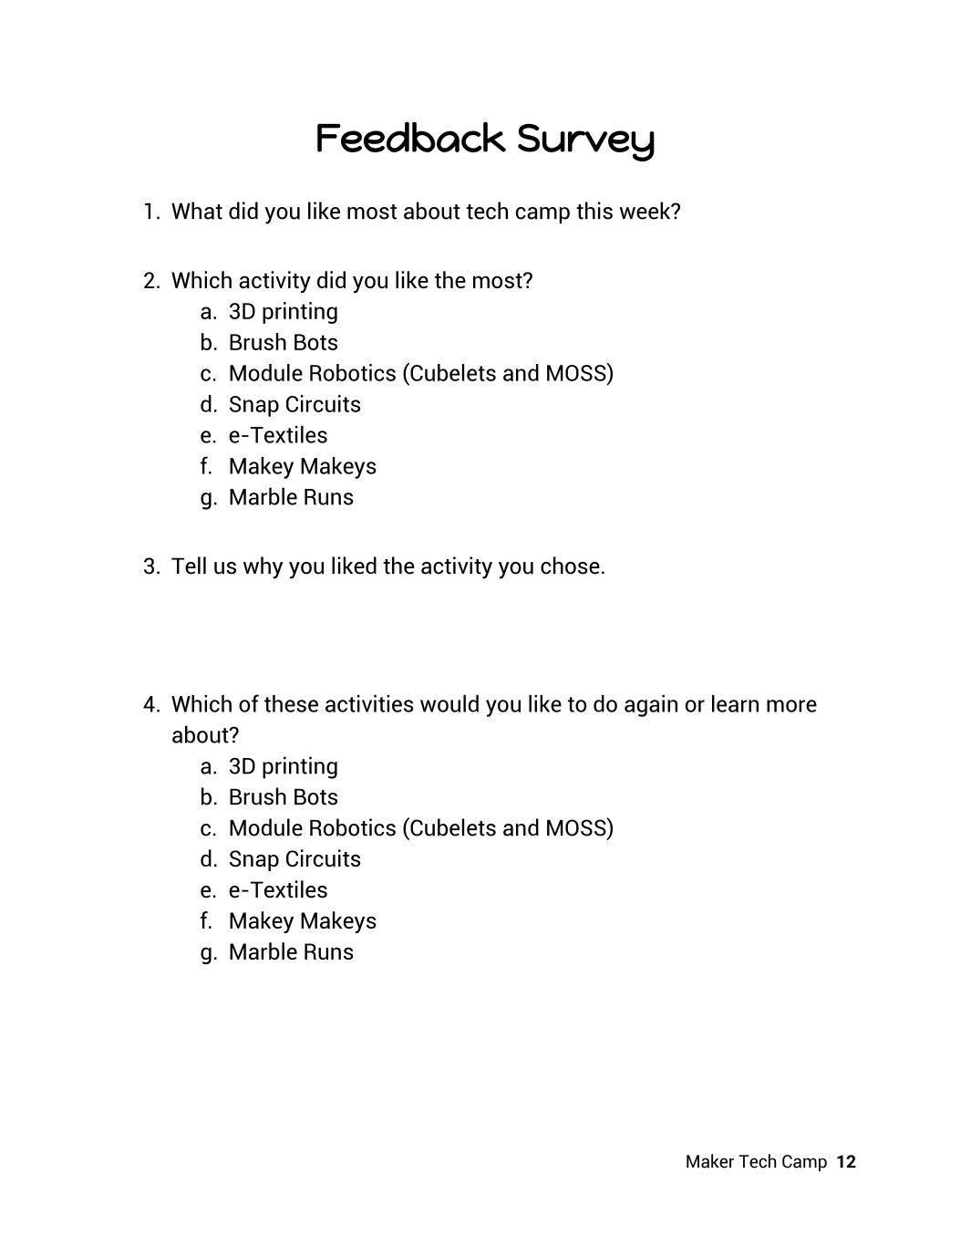On the last day of the camp, the students should fill out this survey to help you improve for next year. Consider creating a version of this survey using google forms. Also consider creating a survey to give to the parents.

Don’t forget to have them fill out the “After Class” part of the survey on page 1!

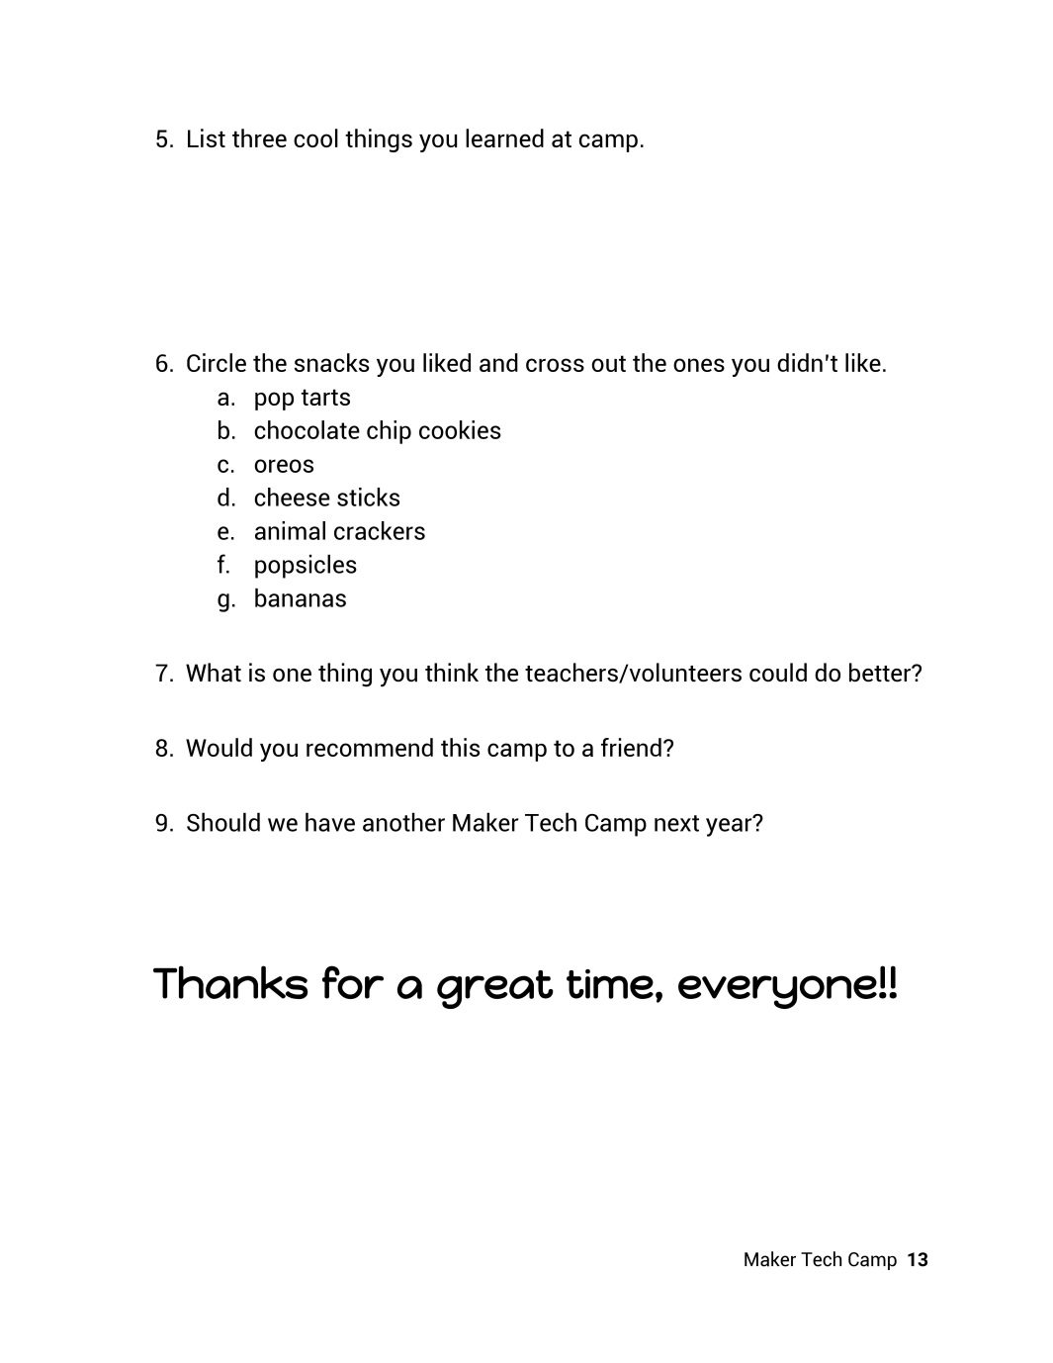Don’t forget to thank the kids for what a great time you had at camp, and send them home with their journals.

**Additional Resources:**

Check back next summer on Team Neutrino’s website ([www.teamneutrino.org](http://www.teamneutrino.org)) for more lesson plans so you can mix and match activities for a new camp.

Check out these sites for tons of ideas!

Make: News <http://makezine.com/blog/>

Maker Faire <http://makerfaire.com/>

Maker Shed <http://www.makershed.com/>

MakerCon <http://makercon.com/>

Maker Camp <http://makercamp.com/>

**Let us know how your Maker Tech Camp went!**   
Go to <http://www.teamneutrino.org/about-us/contact-us/> and email the current team Co-Captain. Thanks!